PROJECT INFO
Project title | Soil Erosion and Torrential Flood Prevention: Curriculum Development at the Universities of Western Balkan Countries
Project acronym | SETOF
Project reference number | 598403-EPP-1-2018-1-RS-EPPKA2-CBHE-JP  (2018-2579/001-001)
Coordinator | University of Belgrade
Project start date | November 15, 2018
Project duration | 36 months

DOCUMENT CONTROL SHEET
Ref. No and Title of Activity | WP5 Dissemination of project results
Title of Deliverable: | 5.3 Promotion material created
Institutions: | University of Belgrade
Author/s of the deliverable | Siniša Polovina, Aleksandar Baumgertel
Status of the document: | final

The most important print material for project promotion is the posters, roll-ups and project brochure, designed to briefly present objectives and outcomes of the project. Posters and roll-ups are printed materials that can be used to promote project at different events (Figure 1 and 2). Project brochure is designed with the idea to present briefly main information about the SETOF project to potentially interested parties. Text in the brochure gives short info on the type of the project, partners involved, main and specific objectives as well as the goals. The project brochure was written in Serbian and English (Figure 3 and Figure 4). Leaflet for master curriculum shows the basic information and structure of the study program with a list of compulsory and elective courses, as well as additional information about the enrollment. The leaflet for the master curriculum is written in Serbian and Bosnian (Figures 5, 6, 7).
Other print materials such as bag, USB flash drive, notebook, pencil, and folder (Figures 8-12) can be used as a promotional material at different events (conferences, workshops, meetings, seminars) and during realization of project activities such as trainings for citizens and public sector, introduction campaign for enrolment students at newly developed master curricula and student and staff mobility.
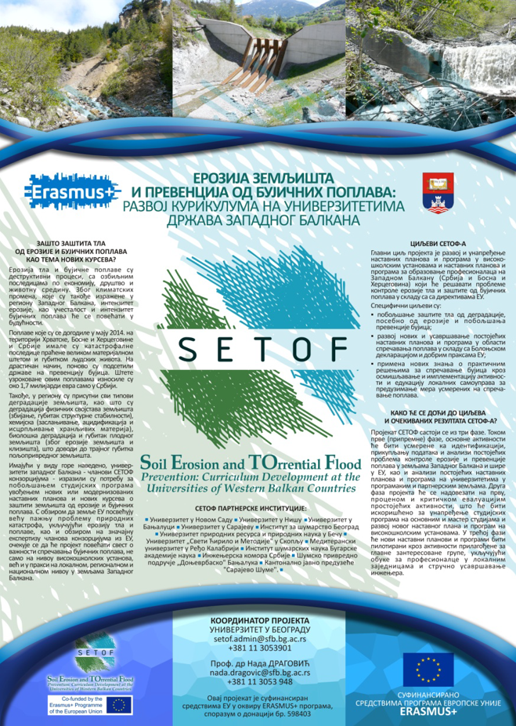
Figure 1. Poster

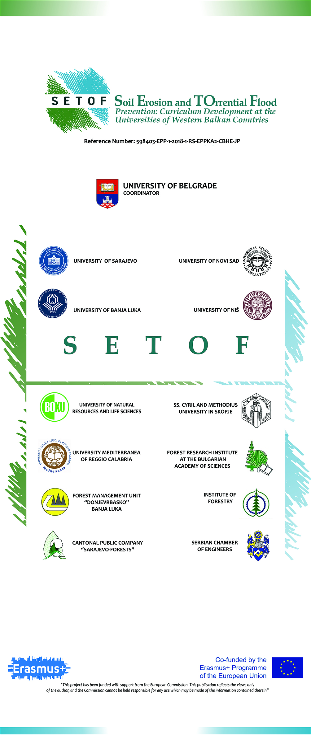
Figure 2. Rollup

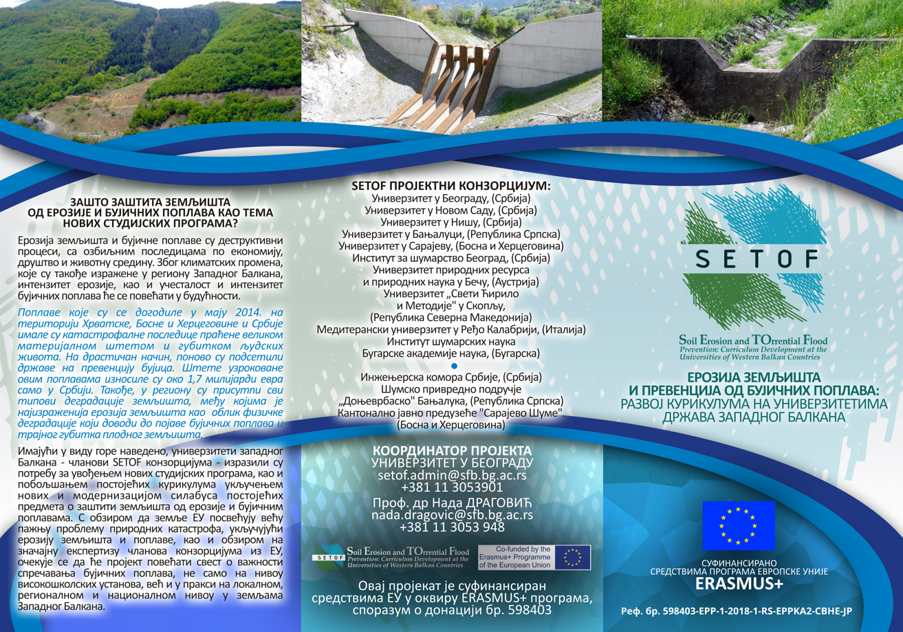
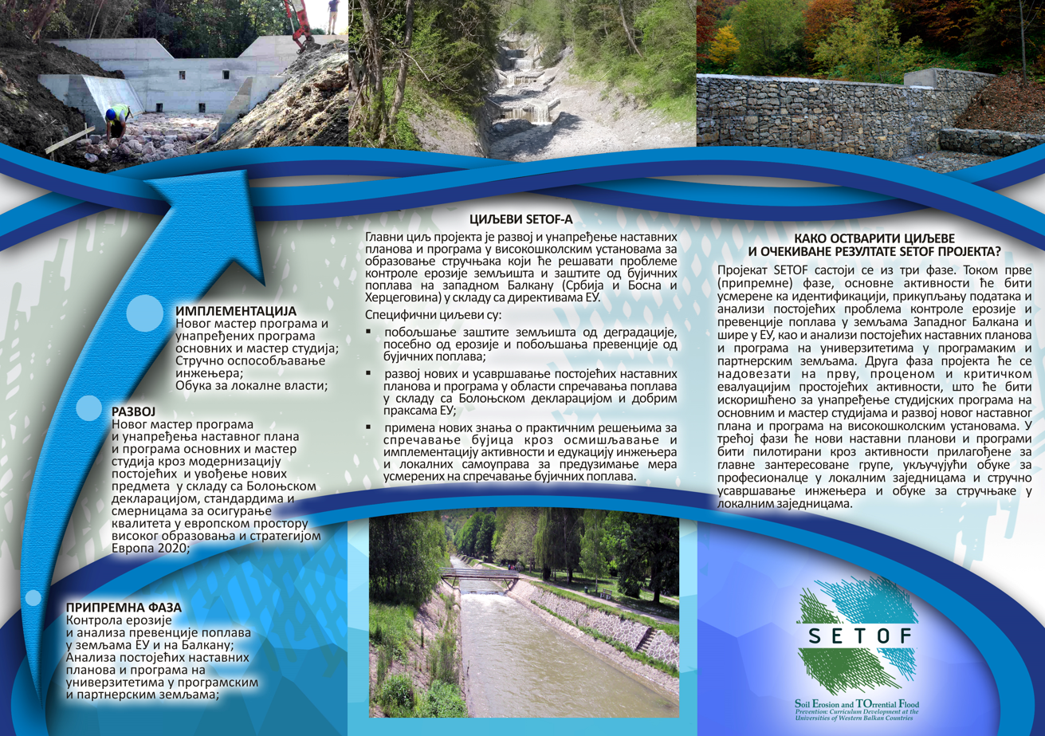
Figure 3. Project brochure (front and back page) in Serbian

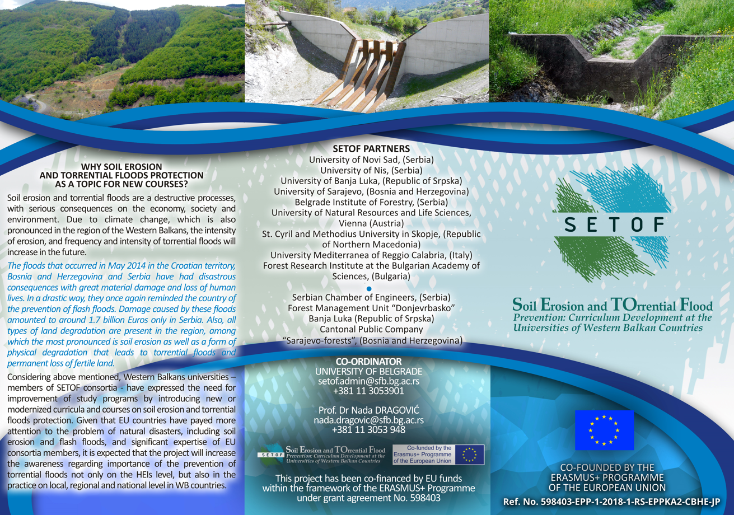
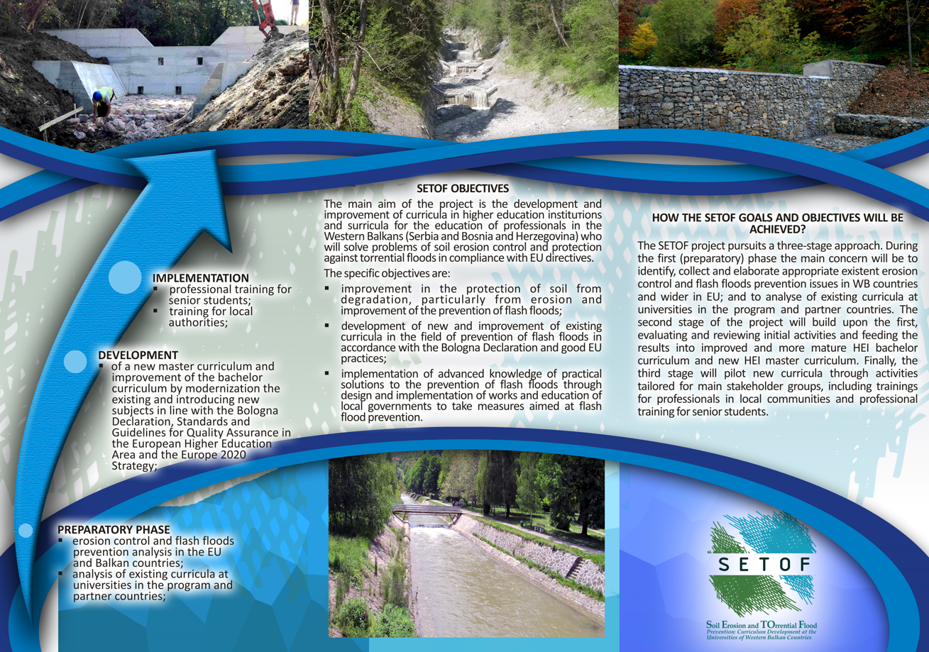
Figure 4. Project brochure (front and back page) in English

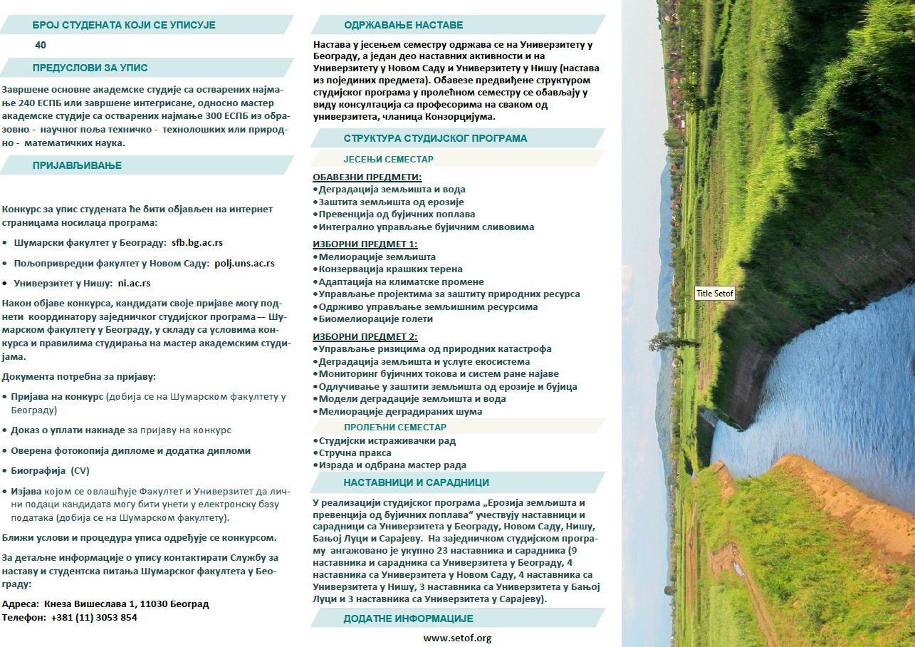
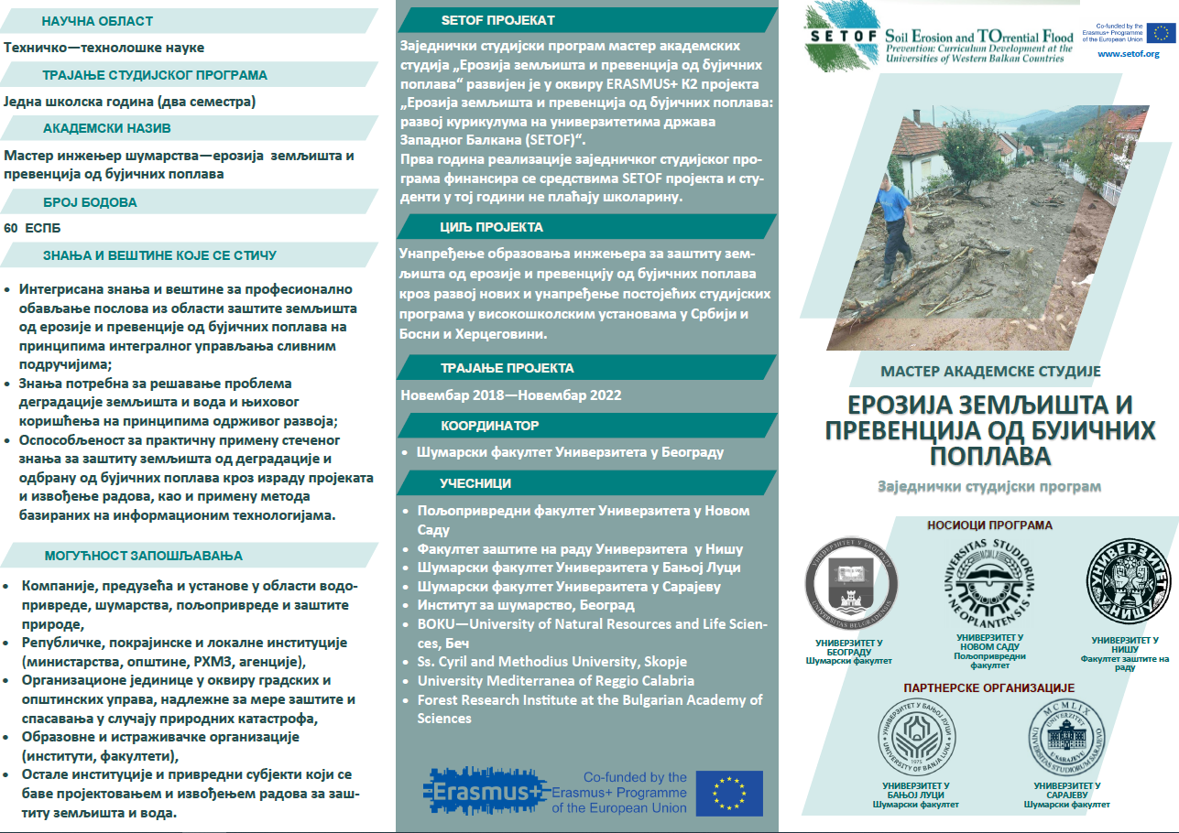
Figure 5. Leaflet for the master curriculum (front and back page) in Serbian language for students from Republic of Serbia

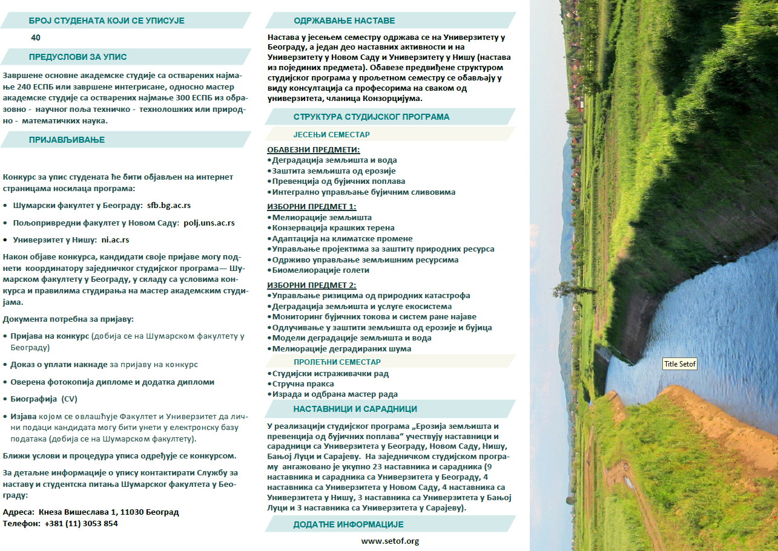
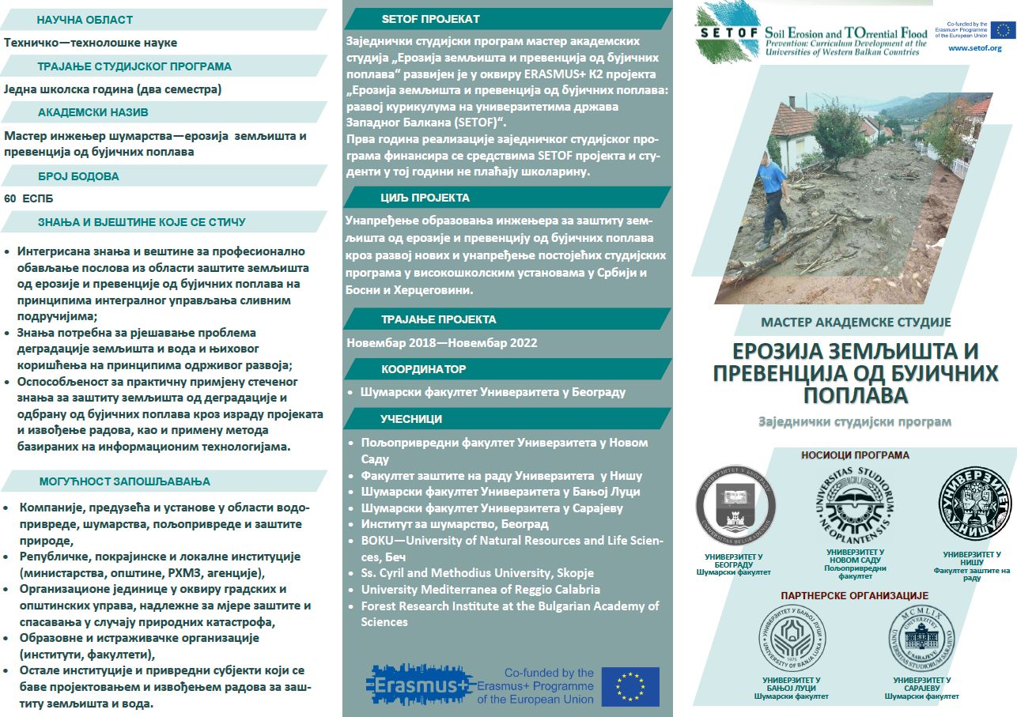
Figure 6. Leaflet for the master curriculum (front and back page) in Serbian language for students from Republic of Srpska

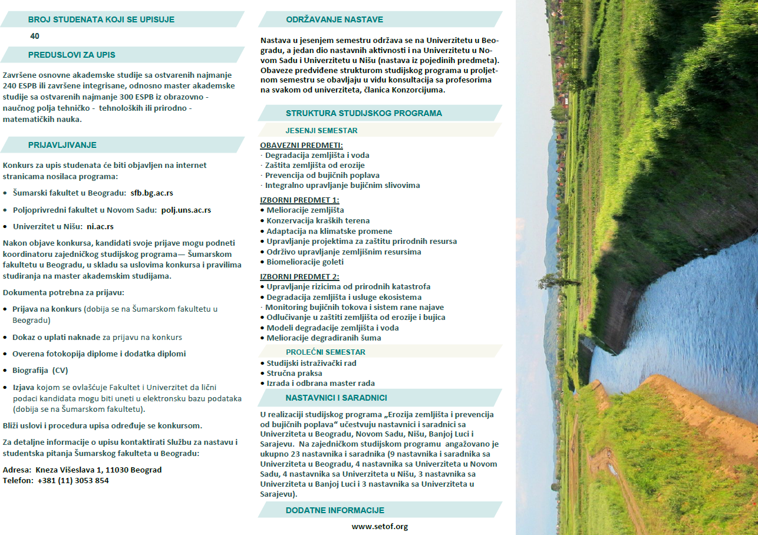
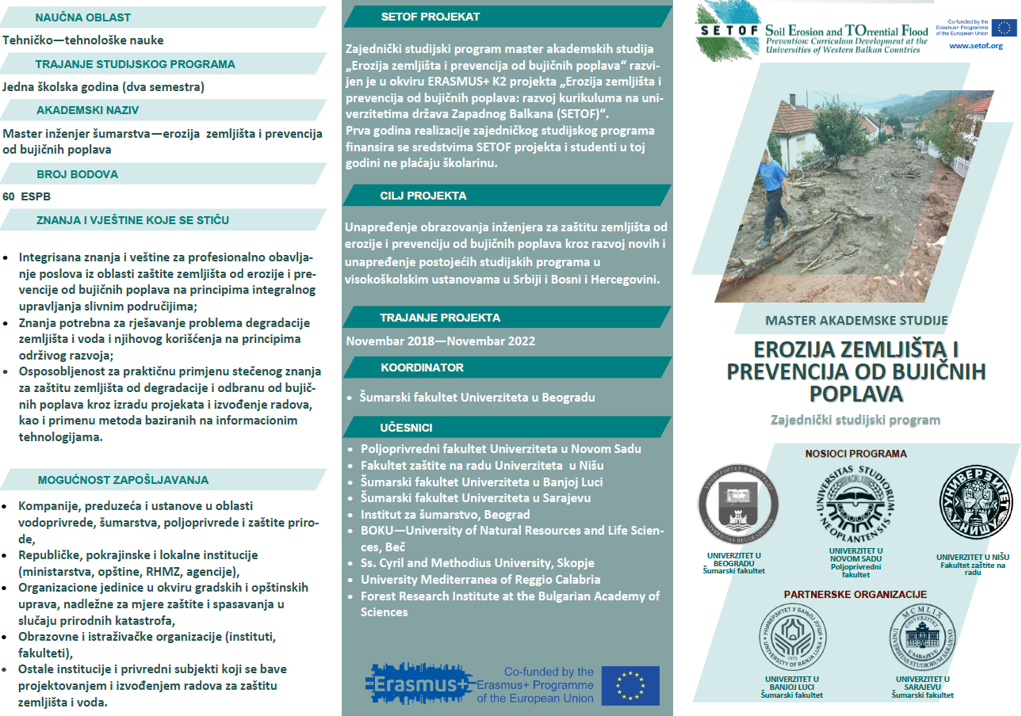
Figure 7. Leaflet for the master curriculum (front and back page) in Bosnia language for students from Federation of Bosnia and Herzegovina

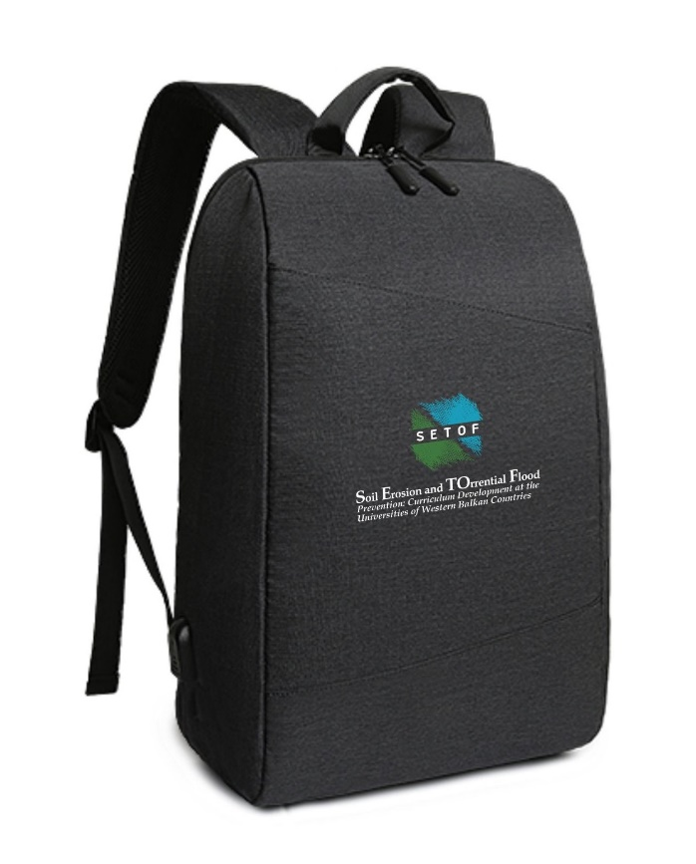
Figure 8. Project bag with SETOF logo

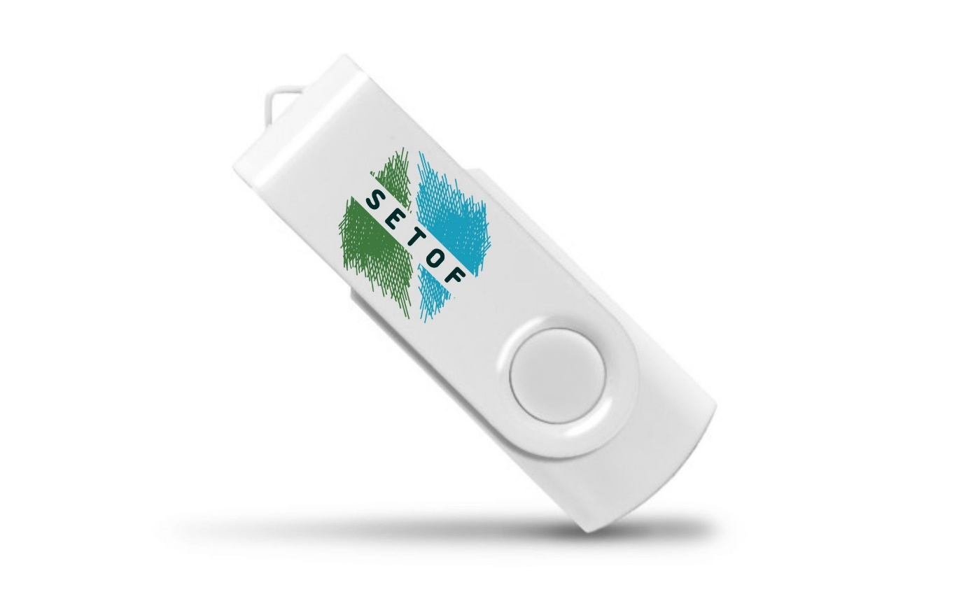
Figure 9. USB Flash drives with SETOF logo

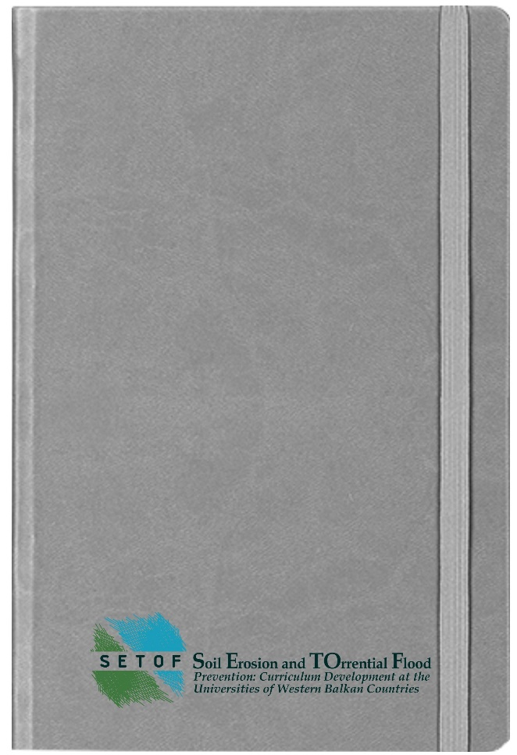
Figure 10. Notebook with with SETOF logo

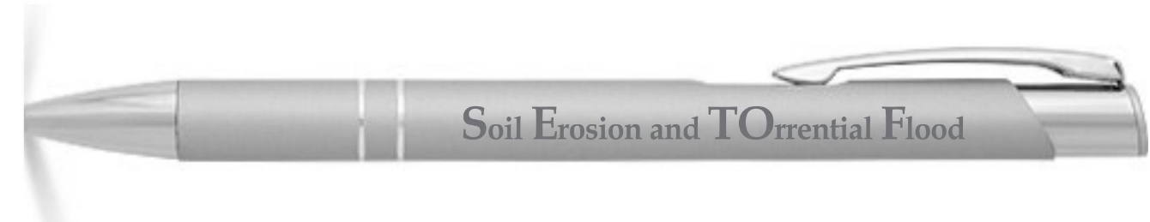
Figure 11. Pencil with SETOF logo

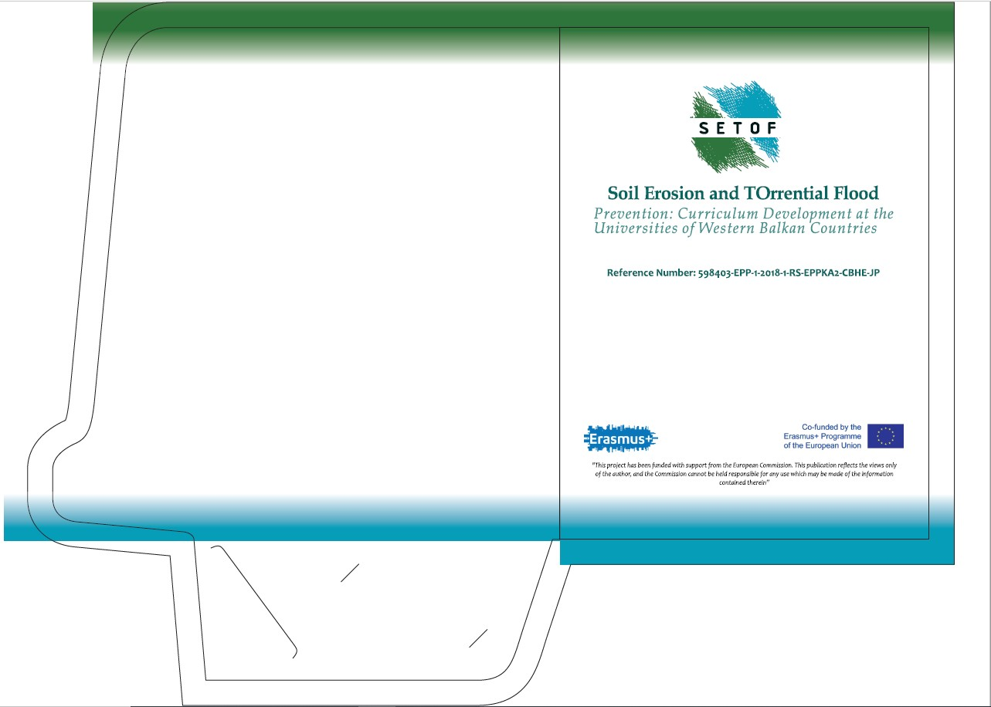
Figure 12. Folder with SETOF logo

